LockedMe.com

# Spirit Planning:

|  |  |  |  |  |
| --- | --- | --- | --- | --- |
| **S. No** | **Task Name** | **Features** | **Duration** | **Status** |
| 1 | Spirit 1 | * Developing Welcome Display * Developing Menu * Coding Business level operation and close | 5 Days | Completed |
| 2 | Welcome Display | Coding for Display the welcome and  Developer details | 1 Day | Completed |
| 3 | Menu | Coding for menu interface, consisting of options   * File lists * Business level operations * Close | 2 Days | Completed |
| 4 | Business level operations | Coding for providing business level operations and calling the methods add,  delete, search | 2 Days | Completed |
| 5 | Spirit 2 | * Coding for methods add, delete, search * Testing * Documentation | 5 Days | Completed |
| 6 | Coding the methods | * Coding for add () * Coding for delete () * Coding for search ()   And calling them to business level operations | 3 Days | Completed |
| 7 | Testing | Checking whether the coding properly  without any errors | 1 Day | Completed |
| 8 | Documentation | Creating a documentation with all the information about the application | 1 Day | Completed |

**Flow of Application:**

## For Add and Displaying the File List:

* When we first open the application there will be a welcome display with the developer details.
* Under that there will be a menu consisting of options file list, business level operations and close.
* Before choosing the option file list we need to first create some files.
* To do that select business level operations.
* When another interface will be displayed with options add, delete, search, back to menu.
* Select the add option it will ask for the file name to be created.
* Follow the above step to create more file.
* Now select the option back to menu.
* The menu interface will be displayed.
* Now select the option files list, the above create files will be displayed in sorted order.

## For Delete:

* To delete the existing select business level operation in the menu.
* Then an interface with delete option will be displayed.
* Select the delete option, it will ask the file name to be deleted, enter the file name.
* If the entered file name exists, the file will be deleted or else it will display that the file doesn’t exists.

## For Search:

* To search file, select business level operations in the menu.
* Then an interface with search option will be displayed.
* Select the search option, it will ask for the file name to be searched.
* After giving the file name, if the file is found then it will display that the file is found or else it will display that the file is not found.

# Flow Chart:

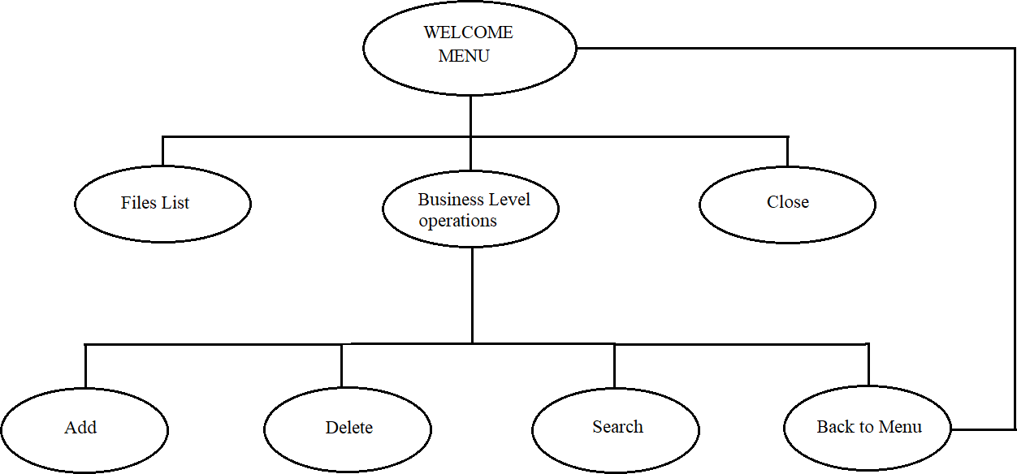

**List of Core Concepts:**

* Object: A Java object is a member (also called an instance) of a Java class. Each object has an identity, a behaviour, and a state.
* Class: Class is a template used to create objects and to define object data types and methods.
* Method: A method is a block of code which only runs when it is called. You can pass data, known as parameters, into a method. Methods are used to perform certain actions, and they are also known as functions.
* Package: Package in Java is a mechanism to encapsulate a group of classes, sub packages and interfaces. Packages are used for: Preventing naming conflicts.
* Constructor: In Java, a constructor is a block of codes similar to the method. It is called when an instance of the class is created. At the time of calling constructor, memory for the object is allocated in the memory. It is a special type of method which is used to initialize the object.
* Strings: Strings are which are widely used in Java programming, are a sequence of characters. In the Java programming language, strings are objects. The Java platform provides the String class to create and manipulate strings.
* Scanner: Scanner is a class in java. util package used for obtaining the input of the primitive types like int, double, etc. and strings next () function returns the next

token/word in the input as a string and charAt(0) function returns the first character in that string

* Loops: The Java for loop is a control flow statement that iterates a part of the program’s multiple times. The Java while loop is a control flow statement that executes a part of the programs repeatedly on the basis of given Boolean condition
* Switch: A Java switch statement is a multiple-branch statement that executes one statement from multiple conditions.
* Exceptions: An exception is an event, which occurs during the execution of a program, that disrupts the normal flow of the program's instructions.
* File: Java File class represents the files and directory pathnames in an abstract manner. This class is used for creation of files and directories, file searching, file deletion, etc. The File object represents the actual file/directory on the disk.

# Algorithm:

1. Package menu
2. import java.io.File
3. import java.io.IOException
4. import java.util.Scanner
5. import businessLevelOperations.operations
6. print welcome
7. print the developer details
8. declaring the file path
9. define an object sc for scanners
10. Start while(true)
11. Print menu
12. Print option 1.file list 2. Business level operations 3. Close
13. Declaring int choice= sc
14. Switch(choice)
15. Case 1 File Lists
16. define an object f for file
17. print list of files
18. start for loop (file ff: file name)
19. print (ff.getname)
20. break;
21. Case 2 Business Level Operations
22. create another package for business level operations
23. import that package with object op
24. scanner= sc1
25. redirecting to another interface
26. print operations 1.Add 2.Delete 3.search 4.back to menu
27. int choice = sc1
28. switch(choice)
29. case 1 Add
30. create another package for add
31. import that package with object ad
32. declaring the file path
33. scanner = sc2
34. print enter the file name to be created
35. string filename = path+sc2
36. importing file with object f
37. result= f.createNewFile();
38. if result=false
39. print file not created
40. else
41. print file create
42. break;
43. Case 2 Delete
44. create another package for delete
45. import that package with object de
46. declaring the file path
47. scanner=sc3
48. print enter the file name to be deleted
49. if(f.delete())
50. print file deleted
51. else
52. print file is not available
53. break;
54. Case 3 Search
55. create another package for search
56. import that package with object srh
57. declaring the file path
58. scanner=sc4
59. print enter the file name to search
60. import file as f with argument path
61. start for ff:filename 62.if(ff.getName().equals(filenameserach)) 63.print file is available
62. else
63. print file is not available
64. break;
65. Case 4 Back to Menu 68.Return to menu 69.Break;
66. Default
67. Print wrong input 72.End while 73.Case 3 Close
68. Print closing the application
69. System exit(0):
70. Default
71. Print wrong input
72. End while

# Conclusion:

In the program an application has been developed with a duration of two spirits. This application makes handling the files of the user easier by listing the file in sorted order, creation, deletion and searching for the files is made more easier and user friendly. So, it can be concluded that with this application the files are more efficiently handled.

## Unique selling points:

* Handling the file is made easier.
* All the file in the folder is displayed in sorted ascending order.
* Create of the file in business level option makes creation of file easier.
* Deletion of the file can directly be done from the application only, if the file to be deleted when it shows that the file doesn’t exists.
* Searching the file for the file list can also be done, if the file is not found then if show that file is not available.